**Communication Methods that Make Sense**

### Communication Methods that Make Sense – and Make Your Point (Skillsoft Professional)

WBT comm_35_a02_bs_enus

Today people rely more and more on mobile devices and 'one-way' communication tools that they often use under the guise of being 'social.' Although it's possible to learn to communicate interpersonally using only technology, it's not always the best or most efficient way to achieve your intended communication outcomes, which are most typically to inform, give feedback, or influence. Interpersonal communication is just that – personal. So the further you stray from communication methods that are rich in personal attributes (you can hear someone, see someone, use body language, interact with others) versus light in personal attributes (impersonal, one-way, static), the more apt you are to have a one-way, 'telling' type of communication. In this course, you'll **learn how to select the best communication methods to convey your intention and target your audience.** By doing so, you improve the odds of getting your message across, making your point, and leaving your audience feeling informed, enlightened, and engaged.

Inform

Feedback

Influence

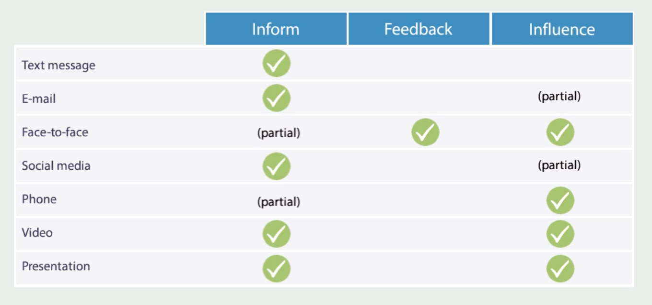

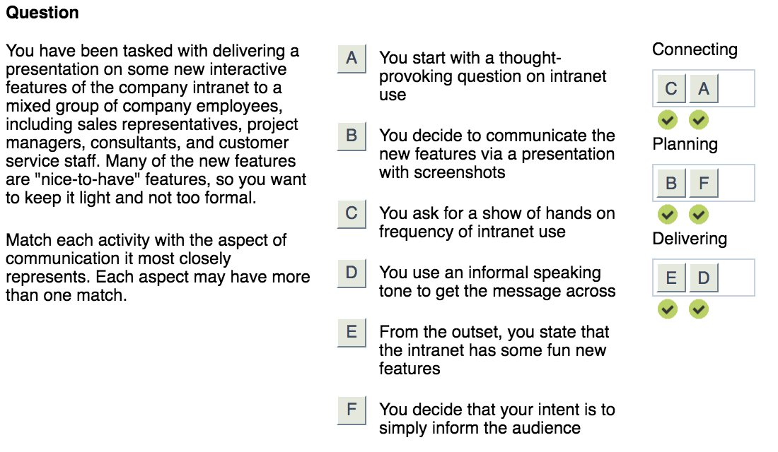

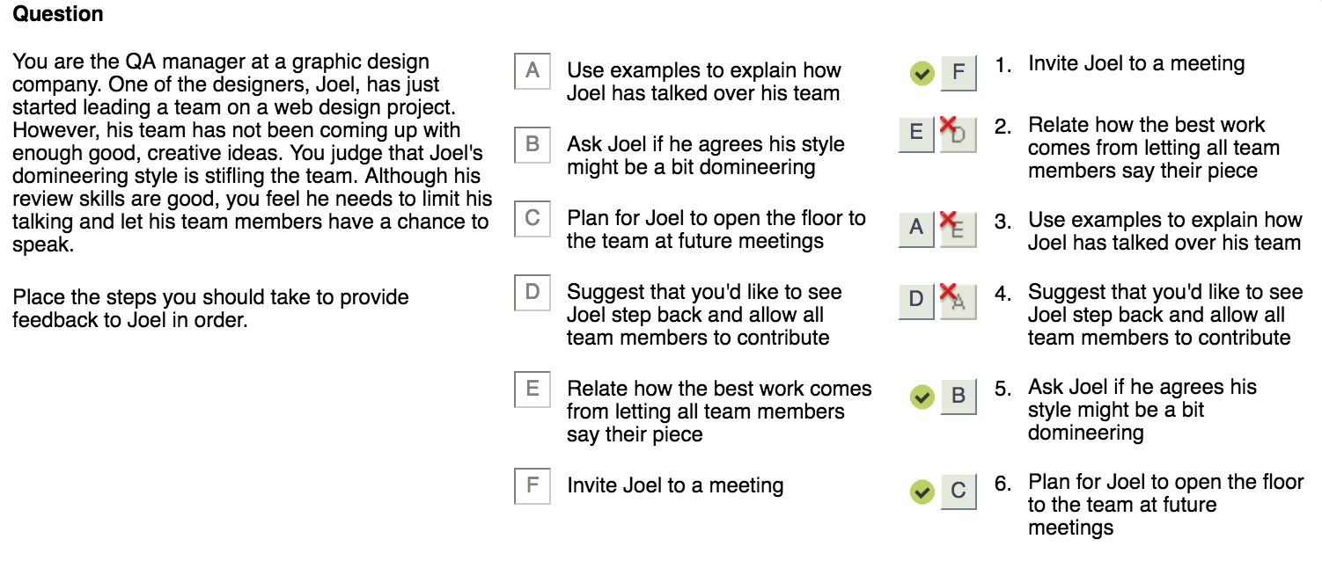

Considering other factors when communicating

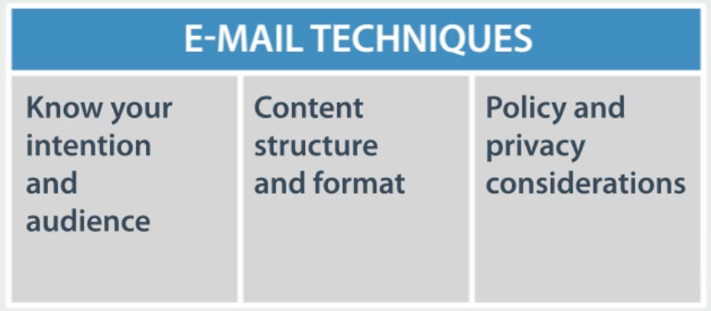

**Face to Face**

**Planning**

* + Intention
  + Audience
  + Time, Time zones
  + Group size
  + Location
  + Technology

**Delivering**

* + Establish context early on
  + Focus on the intention / Message
  + Non-verbal need to match the verbal
  + Inflection for key points
  + Eye contact
  + Smile
  + Gestures

**Connecting**

* + Reach out via email / text
  + Add a question to the invite
  + Pop quiz
  + Ask questions
  + Stories
  + Engage in activities and challenges

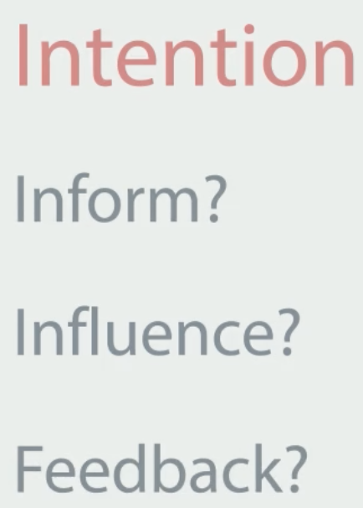

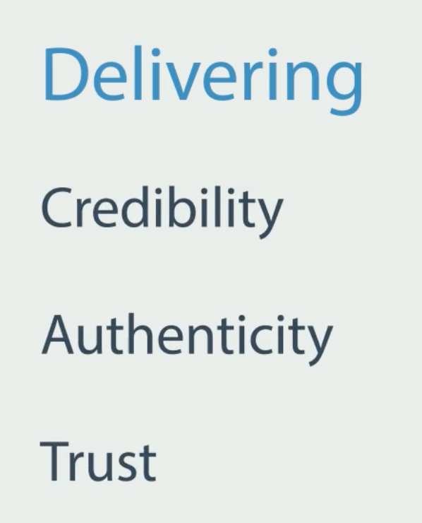

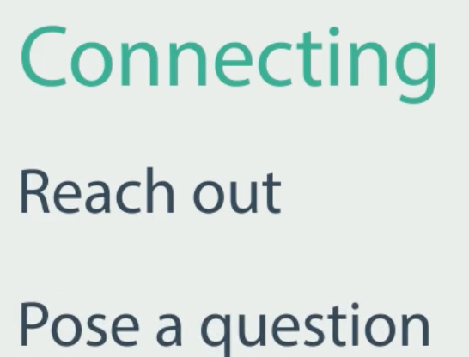

**(Constructive) Feedback**

* Invite – friendly body language
* Relate – to a specific business reason
* Explain – use examples and emotional intelligence
* Suggest – a solution, what you would like to see instead
* Involve – the other person
* Plan – work together for a change

Respect and sensitivity

Show empathy

Don’t take back the feedback

Rely on the process